GLOBAL SALES AND FINANCIAL PERFORMANCE DASHBOARD
Using Microsoft Power BI
Project Report

Submitted By
Name : DHARSHINI
Tool Used : Microsoft Power BI Desktop

Introduction
For this project, I developed an interactive Northwind Sales Dashboard using Microsoft Power BI. The purpose of the project was to analyse orders, sales, quantity sold, freight, customer information, employee-wise orders, monthly order trends, and category-wise sales using the Northwind dataset.
The dataset contains information related to customers, products, categories, employees, orders, regions, quantities, sales, and freight. These fields provide useful information for understanding the overall sales and order performance of the business.
The main purpose of the dashboard was to convert raw sales and order data into a simple and interactive visual report. Instead of analysing large amounts of data manually, users can use KPI cards, charts, and filters to understand important business information quickly.
The dashboard provides an overview of total orders, total quantity sold, total freight, average freight, number of customers, monthly orders, employee-wise orders, and category-wise sales.
Objectives
The main objectives of developing this dashboard were:
- To analyse the overall sales and order performance of the business.
- To calculate and display important KPIs such as total orders and total quantity sold.
- To analyse the number of orders across different months.
- To compare orders handled by different employees.
- To analyse sales across different product categories.
- To understand freight-related information.
- To analyse the number of customers.
- To provide interactive filters for exploring the data.
- To present sales and order data in a simple and understandable visual format.
- To understand how Power BI can be used for business data analysis and decision-making.

Dataset Description
The project uses the Northwind dataset, which contains information about customers, orders, employees, products, categories, regions, quantities, sales, and freight.
The major fields used for the dashboard include:
Field | Description
Order ID | Unique identifier for each order
Customer ID | Identifier for the customer associated with an order
Employee Name | Employee associated with the order
Product Name | Name of the product ordered
Category Name | Category to which the product belongs
Region | Geographical region associated with the order
Order Date | Date on which the order was placed
Month Name | Month in which the order was placed
Quantity | Number of products ordered
Sales | Sales amount generated from the order
Freight | Freight cost associated with the order

The dataset provides sufficient information to analyse order, sales, customer, employee, product, and freight performance from different business perspectives.

Data Preparation
Before creating the dashboard, I prepared the dataset in Microsoft Power BI Desktop.
The main steps followed were:
- Imported the Northwind dataset into Power BI.
- Checked the available columns and their data types.
- Verified the Order ID and Customer ID fields.
- Checked the Employee Name field for employee-wise analysis.
- Checked Category Name for category-wise analysis.
- Verified the Region field for geographical filtering.
- Checked Order Date and Month Name for monthly analysis.
- Verified numerical fields such as Quantity, Sales, and Freight.
- Ensured that the data was suitable for creating charts and KPI cards.
- Created the required measures for calculating the order and sales-related values.
After completing the data preparation, the required visuals and interactive elements were created.

DAX Measures Used
DAX measures were used in Power BI to calculate important sales and order indicators.

- Total Orders
This measure calculates the total number of orders in the selected data.
    - Purpose:
It provides an overall view of the number of orders received by the business.
- Total Quantity Sold
This measure calculates the total quantity of products sold.
    - Purpose:
It helps understand the volume of products ordered during the selected period.
- Total Freight
This measure calculates the total freight amount associated with the orders.
    - Purpose:
It helps analyse the overall freight cost related to the orders.
- Average Freight
This measure calculates the average freight amount per order.
    - Purpose:
It provides an understanding of the average freight associated with the orders.
- Number of Customers
This measure calculates the number of customers represented in the selected data.
    - Purpose:
It helps understand the customer base associated with the orders.

Dashboard Components
The dashboard contains different visualisations, with each visual providing a different view of the business performance.
1. Total Orders by Month
A line chart is used to display the total number of orders across different months.
The chart shows the order trend from January to December.
For the selected year 2014, the chart shows changes in the number of orders throughout the year. The order count increases towards the end of the year, with December showing a noticeable increase.
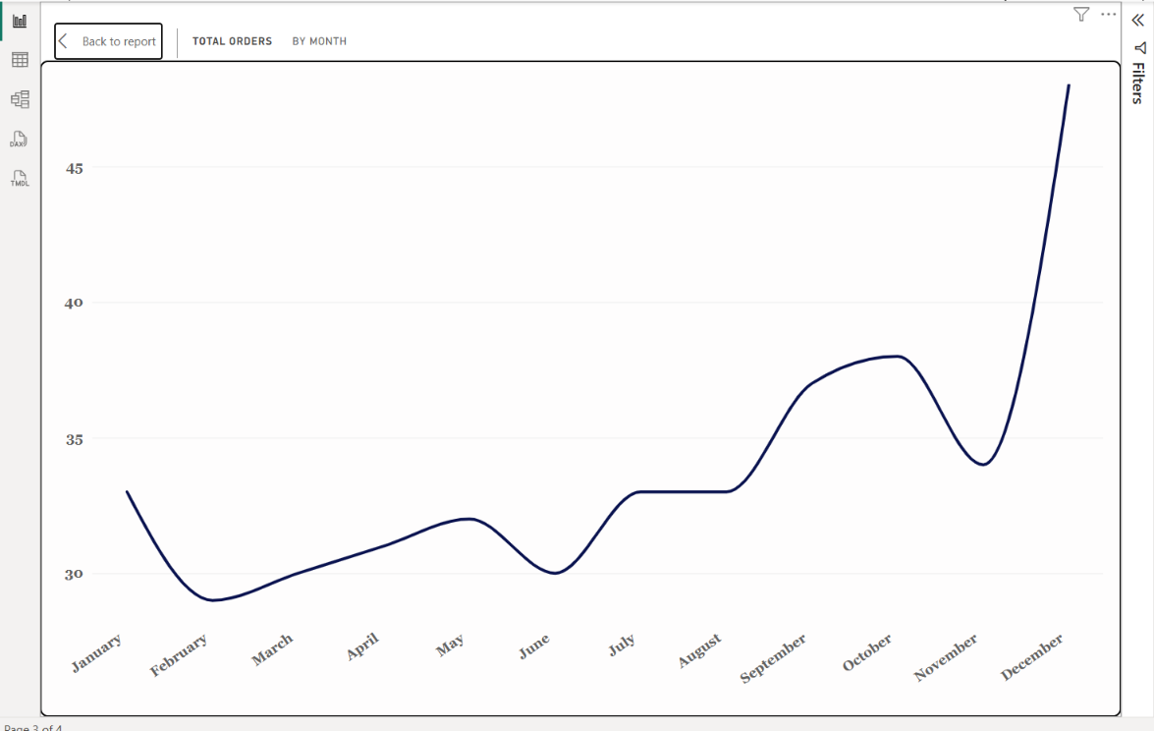
This visual helps identify periods with relatively higher and lower order activity.
2. Total Orders by Employee Name
A horizontal bar chart is used to compare the total number of orders associated with different employees.
The dashboard displays employees such as:
- Margaret Peacock
- Janet Leverling
- Nancy Davolio
- Laura Callahan
- Robert King
- Michael Suyama
- Anne Dodsworth
- Steven Buchanan
The chart allows users to compare the number of orders handled by different employees.
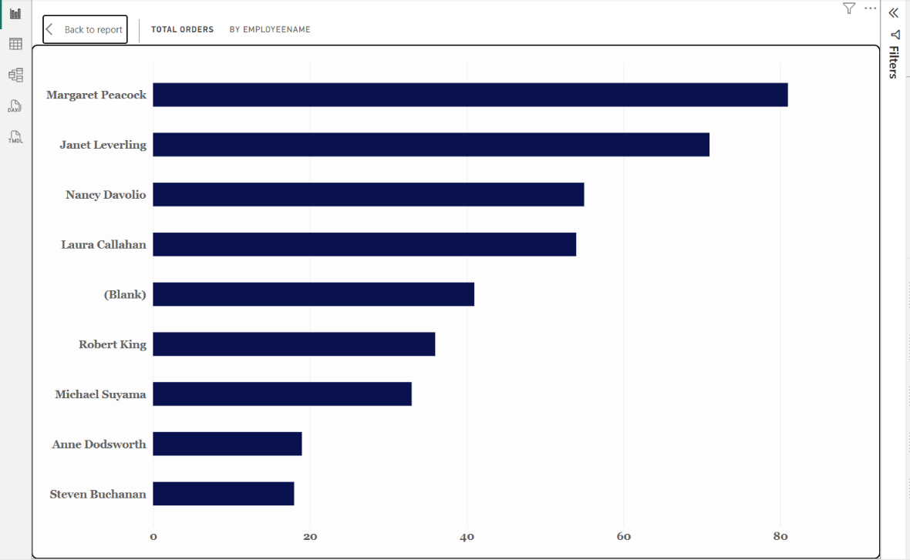
It provides a simple way to understand employee-wise order performance.
3. Total Sales by Category Name
A column chart is used to display total sales across different product categories.
The categories shown in the dashboard include:
- Dairy Products
- Beverages
- Confections
- Meat & Poultry
- Seafood
- Grains & Cereals
- Condiments
- Produce
The chart makes it easy to compare the sales generated by different categories.
From the displayed dashboard, Dairy Products has the highest sales among the categories shown, while Produce and Condiments have comparatively lower sales.
This visual helps understand the contribution of different product categories to total sales.

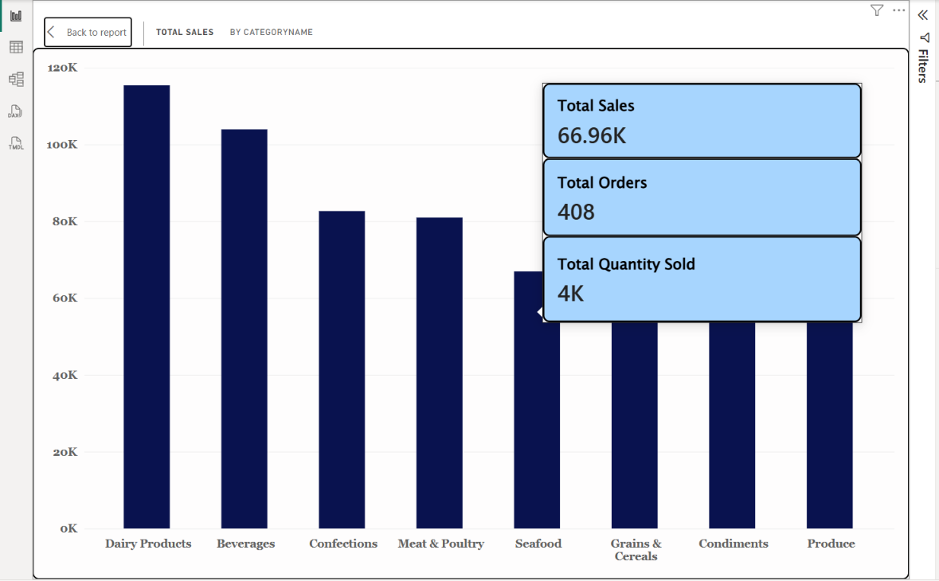
KPI Cards
The right side of the dashboard contains KPI cards that provide a quick summary of important business information.
For the selected year 2014, the dashboard displays:
- Total Orders – 408
- Total Quantity Sold – 25K
- Total Freight – 32.47K
- Average Freight – 79.58
- Number of Customers – 91
These KPI cards provide a quick overview of the order, quantity, freight, and customer information without requiring users to analyse individual charts.

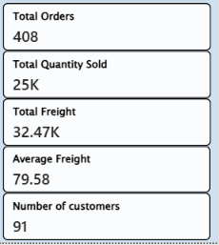

Year Filter
A Year slicer is provided to filter the dashboard based on the selected year.
The available years shown are:
- 2013
- 2014
- 2015
Currently, 2014 is selected in the dashboard.
The Year filter allows users to analyse order and sales performance for a particular year.

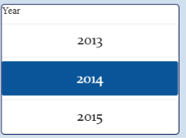

Region Filter
A Region slicer is provided to analyse the dashboard according to geographical region.
Users can select a particular region or choose All to view the overall data.
This filter helps users analyse order and sales information for different regions.

Category Name Filter
A CategoryName slicer is used to filter the dashboard according to product category.
Users can select a specific category or choose All categories.
This allows users to analyse orders and sales related to a particular product category.
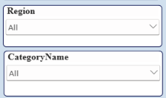
Interactivity of the Dashboard
One of the main advantages of Power BI is that the dashboard is interactive.
When the user selects a value from the Year, Region, or CategoryName slicers, the related charts and KPI values are automatically updated.
For example:
- Selecting a particular year changes the displayed order and sales information for that year.
- Selecting a region allows users to analyse information related to that geographical region.
- Selecting a category allows users to analyse sales and order information for that category.
This makes the dashboard more flexible than a static report because users can explore the data according to their requirements.
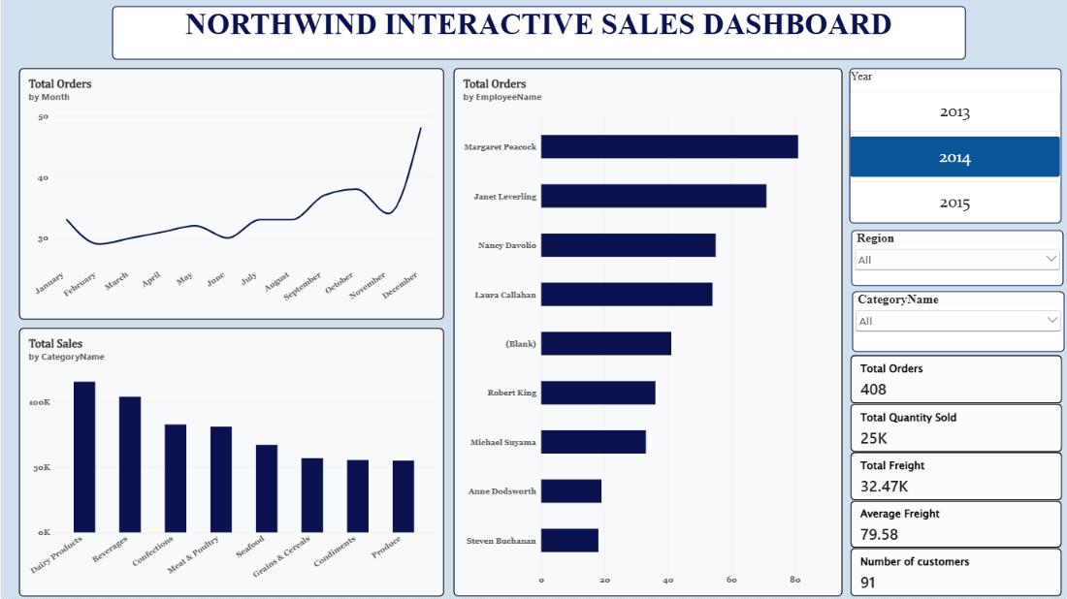

Key Findings
Based on the dashboard, the following observations can be made:
- The selected year in the dashboard is 2014.
- The dashboard shows 408 total orders for the selected view.
- The total quantity sold is displayed as approximately 25K.
- The total freight is approximately 32.47K.
- The average freight is 79.58.
- The dashboard shows 91 customers.
- The monthly order trend changes throughout the year.
- The number of orders shows a noticeable increase towards December.
- Margaret Peacock has the highest number of orders among the employees displayed.
- Sales vary across the different product categories.
- Dairy Products show the highest sales among the categories displayed.
- The dashboard includes categories such as Dairy Products, Beverages, Confections, Meat & Poultry, Seafood, Grains & Cereals, Condiments, and Produce.
- The Year, Region, and CategoryName slicers make the dashboard interactive.
- The combination of KPI cards and charts provides both a quick summary and detailed analysis of the business data.

Conclusion
This project helped me understand how Microsoft Power BI can be used to analyse and visualise sales and order data effectively.
Using the Northwind dataset, I created an interactive dashboard containing KPI cards, a monthly order trend, employee-wise order analysis, category-wise sales analysis, and freight and customer information.
The KPI cards provide a quick overview of total orders, quantity sold, freight, average freight, and number of customers, while the charts provide a more detailed understanding of different aspects of business performance.
The Year, Region, and CategoryName slicers make the dashboard interactive and allow users to explore the data according to their requirements.
Overall, this project improved my knowledge of Power BI, DAX measures, data visualisation, interactive dashboards, and business data analysis. It also helped me understand how raw sales and order data can be transformed into meaningful information for understanding business performance.

